Andrew Jackson’s Destruction of the National Bank

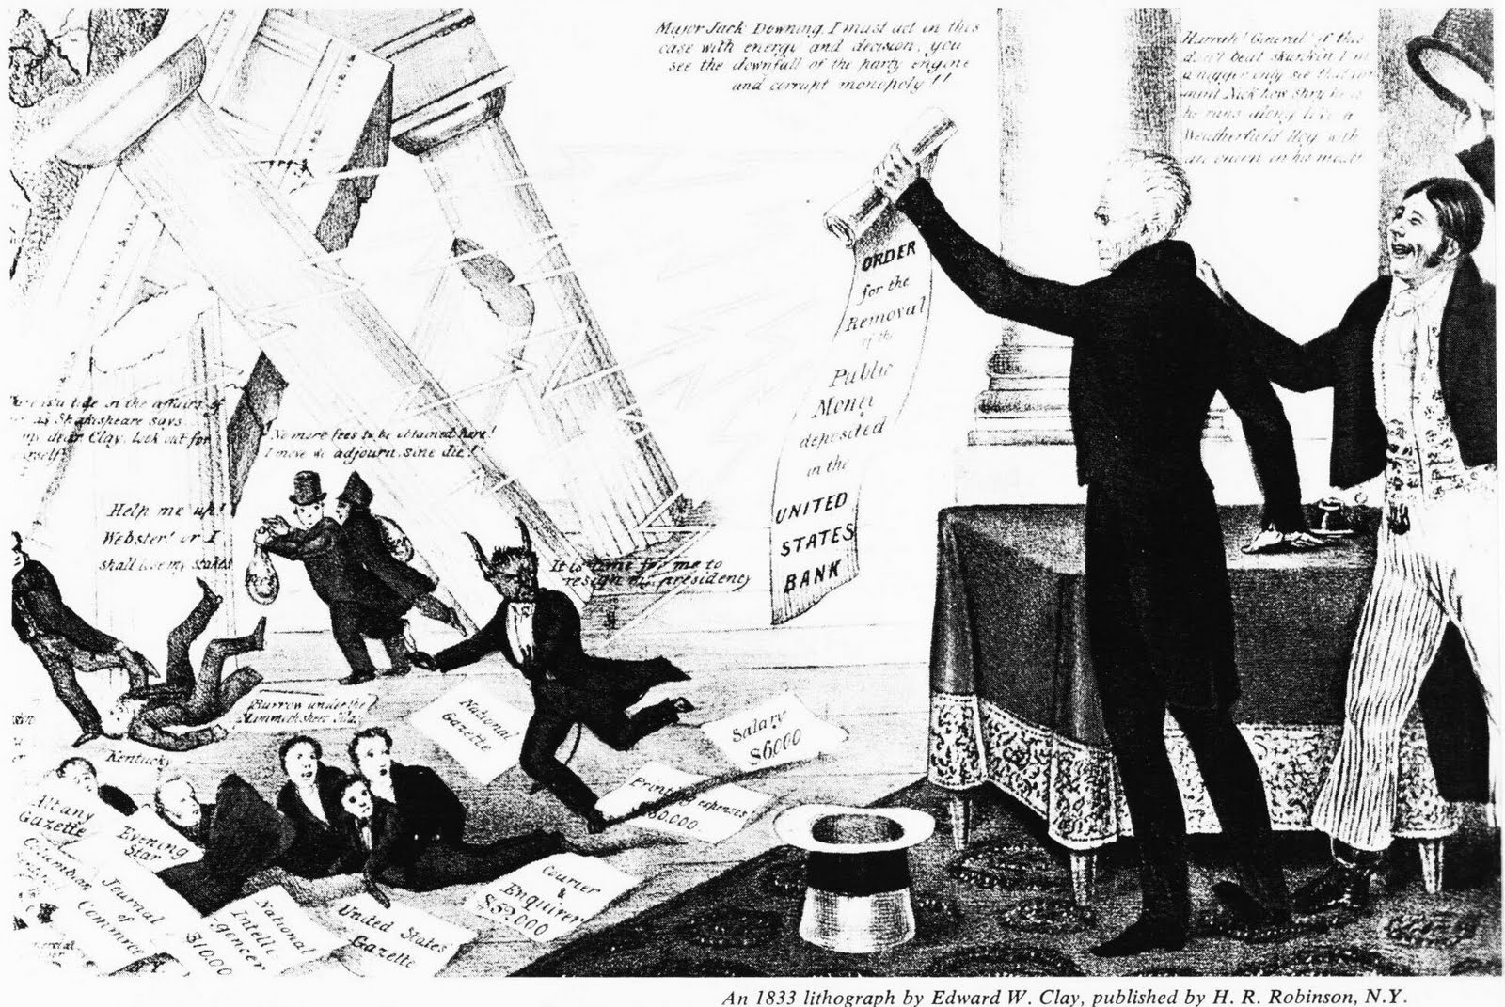

UNDERSTANDING POLITICAL CARTOONS

Study the political cartoon, and then answer the questions that follow.

1. What do the falling pillars represent?

2. Which figure represents the president of the Second Bank of the United States?

3. What is President Jackson holding up?

ACTIVITY

Write a summary for the “destruction” of the Second Bank of the United States. Explain the reasons why Jackson hated the bank and the events that led to the Bank’s demise. In addition, give your opinion on whether or not getting rid of the Bank was a good idea.

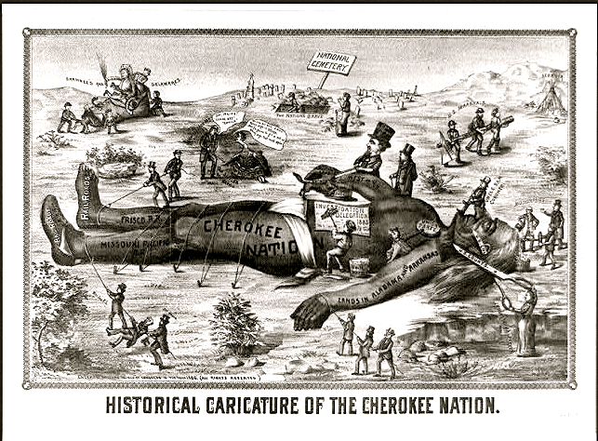

Study the political cartoon, and then answer the questions that follow.

- What is happening to the Native American in this cartoon?

- Which Native American nation is represented?

- Summarize the over all message of the cartoon.

Final Analysis
After analyzing the above cartoons, you are to find one additional political cartoon about Jackson’s presidency or a modern day political issue to analyze. The cartoon image needs to be added to this document and your analysis should include the following:

- Who is depicted in the cartoon?
- What is taking place in the cartoon?
- Does the political cartoon present a bias opinion? If so whose opinion is it?
- What message is being portrayed by the cartoon?

